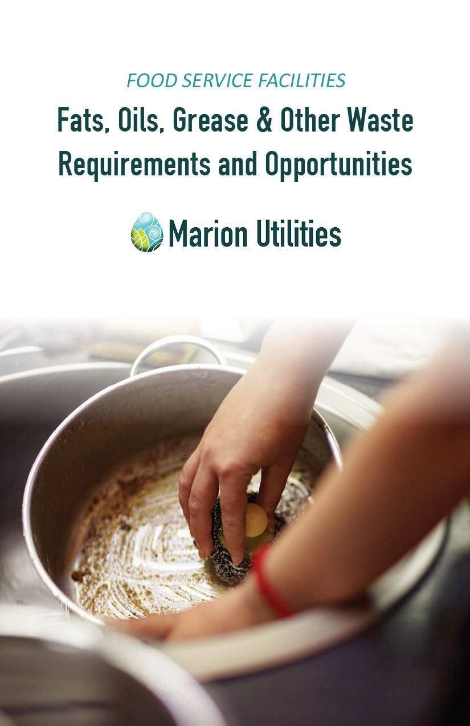

TABLE OF CONTENTS

Introduction 3

What do I have to do? 4

Is a grease trap or interceptor required? 5

What is a grease interceptor? 6

Installation requirements for a grease interceptor 7

What size should the grease interceptor be? 9

What is involved in maintaining a grease interceptor? 9

Who removes the contents from the grease interceptor? 10

How often does the grease interceptor need cleaned? 11

What are best management practices? 12

How do we conduct a periodic inspection? 14

What records need to be kept? 14

What if I can’t install a grease interceptor? 15

What are the installation requirements for a grease trap? 16

How do I clean my grease trap? 17

Food Trucks 19

What is a solids separator? 20

Recycling and material reuse at Marion Utilities 21

Who do I contact if I have questions? 26

INTRODUCTION

Fats, oils, grease and other waste materials generated at restaurants, convenience stores, and other food service facilities can, from Marion Utilities perspective, be both a problem and an opportunity.

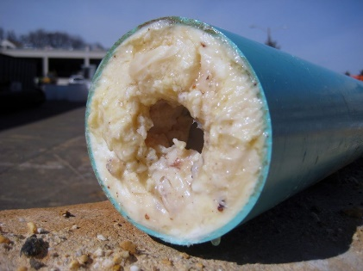

The problem is that oil and grease, when placed in facility drains, causes blockages and corrosion in downstream sewer pipes, requiring sewer pipes to be cleaned or replaced. To address this problem, the installation and maintenance of grease interceptors is required at restaurants, convenience stores and other food service facilities.

The good news is that accumulated oil and grease, when hauled to the wastewater treatment plant, benefits the utility because it increases digester gas and electricity production.

Food service facilities also have the opportunity to improve their environmental footprint by bringing used cooking oil or food waste to the wastewater treatment plant and recycling glass, metal, cardboard, paper, and plastic at the Marion Recycling Center.

WHAT DO I HAVE TO DO?

If your facility serves food or beverages, you should expect to:

* Install and maintain an approved grease interceptor or grease trap.
* Allow utility personnel access to all parts of the premises for the purposes of inspection, sampling, and records examination.
* Properly dispose of fats, oils, and grease that accumulates in the grease interceptor.
* Submit information or reports as requested.

WHERE DO FATS, OILS AND GREASE COME FROM?

Dairy

Coffee

Meat

Bread

Salad dressings

Condiments

Butter, margarine, lard

Cooking oils

WHERE IS THE UTILITIES’ AUTHORITY TO REQUIRE A

GREASE TRAP OR INTERCEPTOR?

Marion Utilities treats wastewater in accordance with a permit issued by the State of Indiana. The permit requires that the Utility establish an ordinance to protect the wastewater collection and treatment systems; this is City of Marion Ordinance 9-2016. In general, the Ordinance authorizes the Marion Utility Service Board to request information, conduct inspections, issue permits, collect samples, and require reports from food service facilities and anyone discharging to the sewer system.

Specifically, Section 2.1 B. (3) of the Sewer Use Ordinance prohibits the discharge of solid or viscous substances in amounts that will cause obstruction of the flow in a sewer system, including, but not limited to, fats, oil, and grease.

In addition, Section 3.2 C. of the Ordinance establishes that grease interceptors shall be provided for the proper handling of wastewater containing excessive amounts of grease and oil. All interception units shall be of a type and capacity approved by the Board and shall be so located to be easily accessible for cleaning and inspection. Such interceptors shall be inspected, cleaned, and repaired by the user at their expense and shall be maintained such that the user does not violate the Ordinance.

The following sections of this document describe Marion Utilities plan to eliminate or control the discharge of animal or vegetable fat, oil, and grease from food service facilities in an equitable, efficient, and flexible manner.

WHAT IS A GREASE INTERCEPTOR?

The required grease interceptor is a large tank or vault located in the ground on the exterior of the building.

The size or capacity of the interceptor is designed to provide adequate holding time so that the wastewater has time to cool, allowing the fats, oils and grease time to congeal and rise to the surface and solids to settle to the bottom where they accumulate until the interceptor contents are removed.

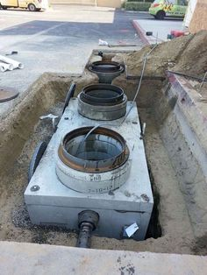

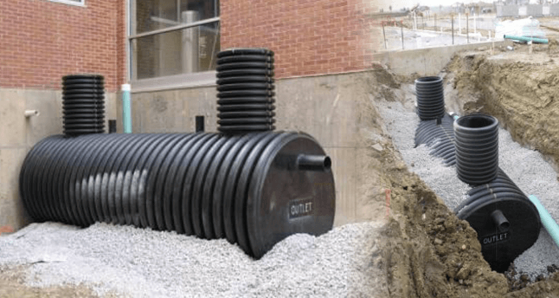

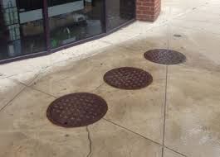

WHAT ARE THE INSTALLATION REQUIREMENTS FOR A

GREASE INTERCEPTOR?

• Install and connect each interceptor so that at all times it is easily accessible for inspection, cleaning and maintenance.

• Construct the external interceptor in such a manner to exclude the entrance of surface water and storm water.

• Place the interceptor on the premises of the food service facility.

• The capacity of the grease interceptor must be at least 1000 gallons.

• Connect all grease-bearing drains to the grease interceptor. These may include mop sinks, woks, wash sinks, prep sinks, utility sinks, pre-rinse sinks, can washes, dishwashers, and floor drains in food preparation areas such as those near a fryer or tilt/steam kettle.

• Do not connect toilets, urinals, restroom sinks and other similar fixtures to the interceptor.

• Follow all applicable state and local plumbing and building codes during installation of the interceptor.

There are many grease interceptor design options available. Please submit design options to the utility for consideration and approval.

TYPICAL DRAIN LINE LAYOUT

H is the depth of the interceptor contents

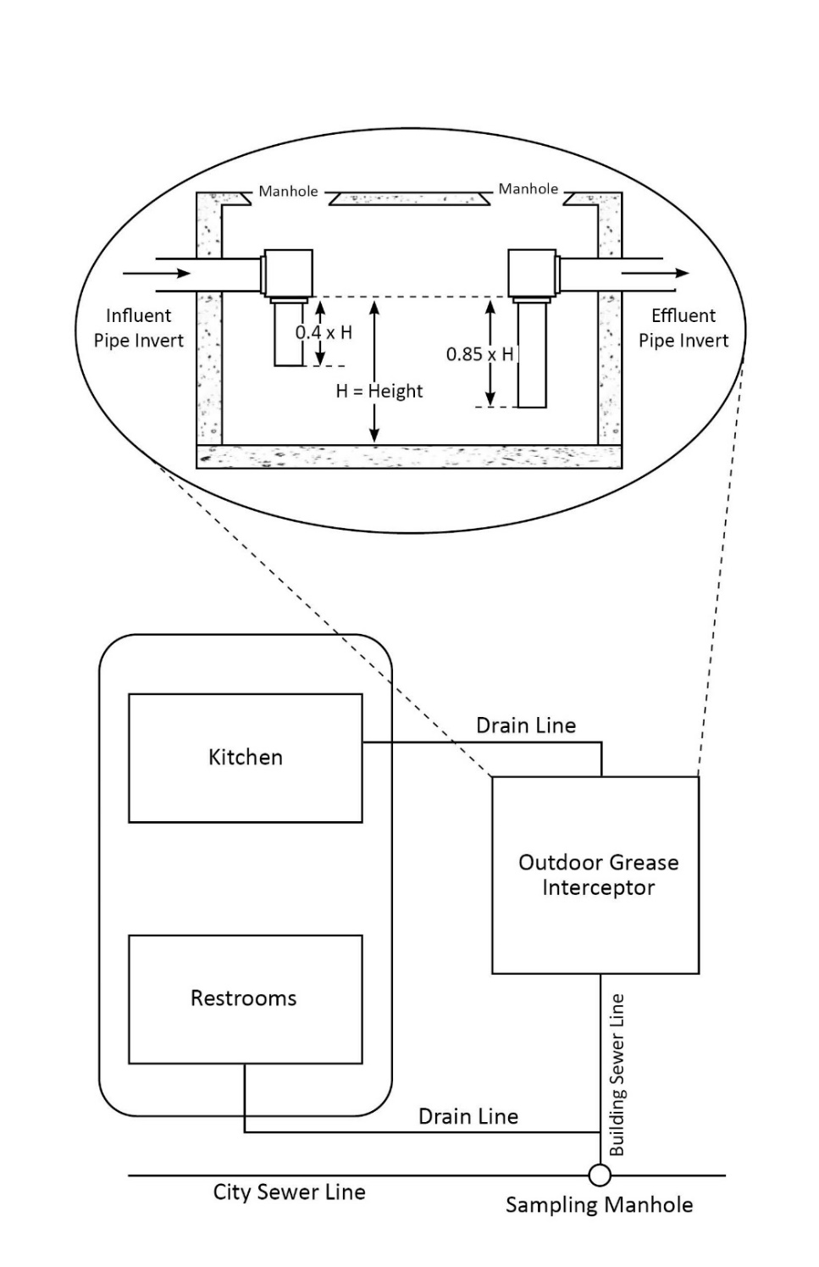

WHAT SIZE SHOULD THE GREASE INTERCEPTOR BE?

Marion Utilities recommends consulting a licensed plumber to calculate grease interceptor sizing per plumbing code. Sizing is based on fats, oils, or grease generated and flow of water from the kitchen fixtures.

WHAT IS INVOLVED IN MAINTAINING A GREASE INTERCEPTOR?

If a grease interceptor is functioning correctly, the grease accumulates at the top and the solid particles settle to the bottom. Maintenance includes periodic inspection of the interceptor, regular removal of the entire interceptor contents, and repairs to the interceptor as needed.

The objective is to remove the entire contents of the grease interceptor before the accumulated grease or solids layers escape from the interceptor through the effluent pipe. It is generally expected that grease and solids will remain in the interceptor until more than 33% of the depth of the interceptor contents is grease or more than 25% of the depth of the interceptor contents is solids or a combination of solids and grease.

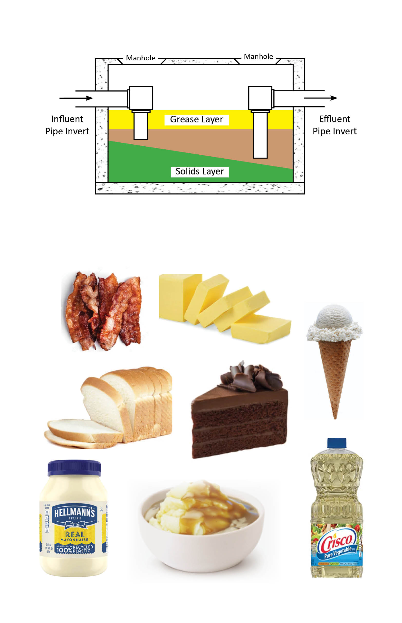

WHO REMOVES THE CONTENTS FROM THE GREASE INTERCEPTOR?

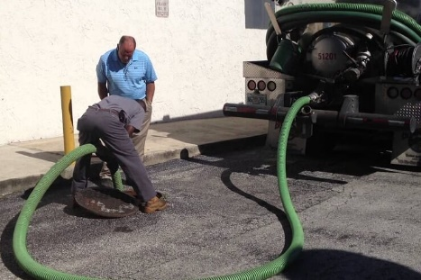Contract with a grease interceptor pumping service for regular removal of the entire interceptor contents. The contractor should scrape all sides and remove all of the tank contents. When emptied, thoroughly wash the interceptor and inspect all interior plumbing connections for completeness and integrity.

Some contractors treat the interceptor wastewater on-site and intend to reintroduce it back into the interceptor after on-site treatment. This practice is prohibited unless Marion Utilities has granted permission. Also prohibited is the use of chemicals, bacteria, enzymes, or other cleaning agents, unless Marion Utilities has approved their use.

The following is a list of grease interceptor pumping contractors that service Marion and are interested in bringing the collected material to Marion Utilities for processing. Mention of services or vendors does not constitute an endorsement by Marion Utilities.

● Chuck’s Sewer & Drain Septic Hauling, Marion - 765-664-2536

● Koorsen Environmental Services, Indianapolis - 317-308-7676 or 317-608-244

HOW OFTEN DOES THE GREASE INTERCEPTOR NEED CLEANED?

Grease interceptor cleaning frequency can vary based on the food processed or served, size of the interceptor relative to the amount of grease produced, and best management practices followed.

The baseline interceptor cleaning frequency is every 90 days unless a different, site specific cleaning frequency has been approved or required. Site specific cleaning schedules will be based on information collected during site visits and will be documented in a permit or other control document.

In the following pages, Best Management Practices are suggested which may extend the time between required cleanings. Periodic inspection measurements and/or compliance monitoring may also indicate that a longer time between interceptor cleaning may be acceptable. If you have adopted some new best management practices or inspection measurements indicate that the volume of grease or solids you are generating has decreased, contact Marion Utilities to request an increase in the number of days between required cleaning frequency.

If you have an existing grease interceptor that is improperly sized for your facility or generate a large volume of grease or solids, then a frequency of less than 90 days may be required.

WHAT ARE BEST MANAGEMENT PRACTICES?

Best Management Practices are things that can be done to improve the effectiveness of the grease interceptor and increase the time required between interceptor cleaning events. The following are some Best Management Practices.

• Remove food waste with “dry wipe” methods such as scraping, wiping, or sweeping before using “wet” methods. Scrape food and grease on pots, pans, and dishware into a food waste container for recycling or into a trash can.

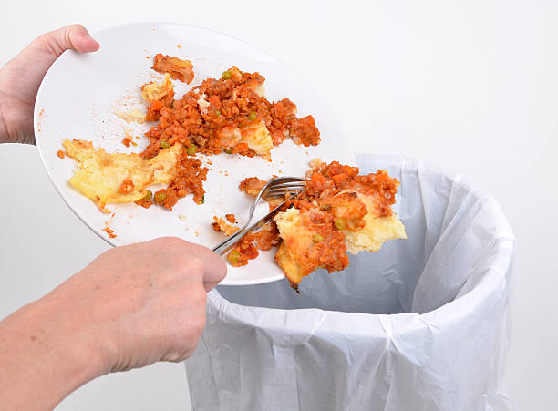

• Use food grade paper to soak up oil and grease and use paper towels to wipe down work areas. Cloth towels will accumulate grease that will eventually end up in your drains from towel washing and rinsing.

• Discontinue the use of garbage grinders. Deposit food waste in a food-recycling container or in the trash!

• Collect fryer oil in an oil-rendering tank for recycling. Move the oil recycle container to a convenient location. Never put oil into a grease interceptor.

• Use proper concentrations of cleaners and disinfectants.

• Use detergents that promote rapid oil/water separation. Some detergents contain surfactants or other chemicals that do not readily allow grease or oil to separate from the water and rise in the grease interceptor.

• Avoid detergents containing enzymes.

• Prevent spills. Empty containers before they are full. Provide employees with the proper tools to transport materials without spilling.

• When using a 3-compartment sink for utensil washing, make sure all drain screens are installed.

• Contract with a professional to clean large hood filters.

• Hand-clean small hoods with spray detergents and wipe down with cloths for cleaning. Effectively clean hood filters by routinely spraying with hot water, with little or no detergent, over a mop sink that is connected to the grease interceptor.

• Make sure all kitchen staff and other employees practice these grease management techniques.

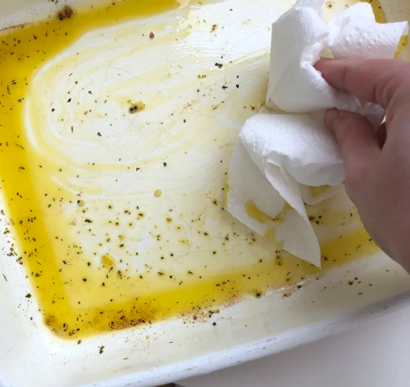

HOW DO WE CONDUCT A PERIODIC INSPECTION?

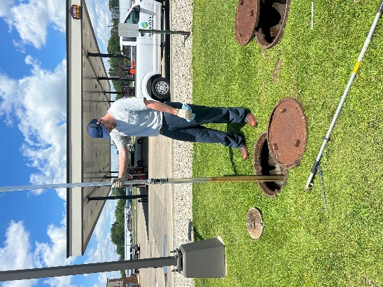Periodic inspections will be conducted by Marion Utilities staff to ensure proper maintenance and cleaning is being performed. If an alternate or extended cleaning frequency is desired, periodic inspection may be required to justify the change in cleaning frequency. Marion Utilities can inspect the interceptor periodically to determine at what rate the interceptor is accumulating grease and solids.

Inspections are performed by sampling the interceptor contents at the interceptor location. Measurements are taken by combining the thickness of the grease and solids layers.

WHAT RECORDS NEED TO BE KEPT?

Maintain dated receipts of interceptor pumping for three (3) years. Make the receipts available for inspection by Marion Utilities, if requested.

WHAT IF I CAN’T INSTALL A GREASE INTERCEPTOR?

In the event that installation or maintenance of a grease interceptor is not feasible, Marion Utilities may consider alternate grease treatment or removal processes.

**Grease Trap:** Grease traps may be approved where fats, oils and grease waste are minimal. Best Management Practices should still be used with the grease trap.

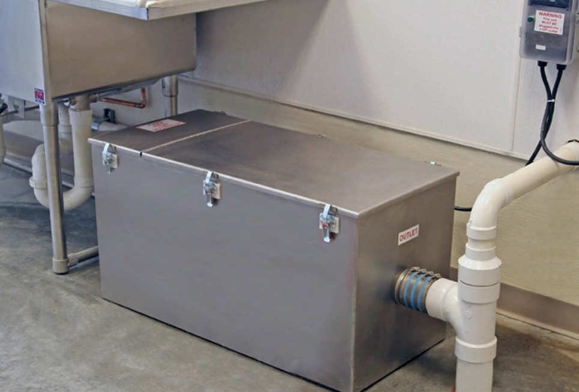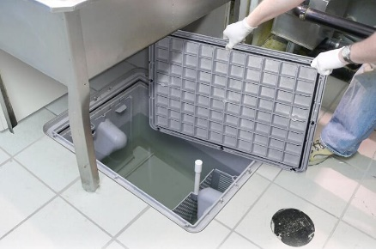A grease trap is a small reservoir built into the wastewater piping a short distance (sometimes under the sink) from the grease producing area.

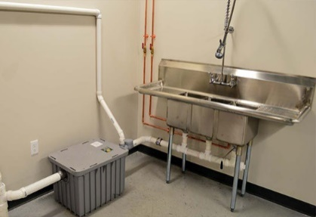

**Biological or Chemical Treatment Technologies**: The use of chemicals, bacteria, enzymes, or other agents in lieu of or in addition to a grease interceptor to control the discharge of fats, oil, and grease is prohibited unless it has been demonstrated that they effectively eliminate or control fats, oil, and grease and Marion Utilities has granted permission for their use.

WHAT ARE THE INSTALLATION REQUIREMENTS FOR A

GREASE TRAP?

• Install grease traps on or in the floor.

• Each grease trap must have a vented flow control device so that the water flow does not exceed the rated flow of the grease trap. The vent is important because the air introduced through the vent (air in-take) becomes entrained with the water and increases separation efficiency.

• Leave 12” or more of clear space above the grease trap to facilitate grease trap cleaning.

• Do not connect automatic dishwashers to grease traps.

• Do not connect garbage grinders directly to a grease trap. Install a solids separating or collection unit before the grease trap if a garbage grinder or excessive solids are present.

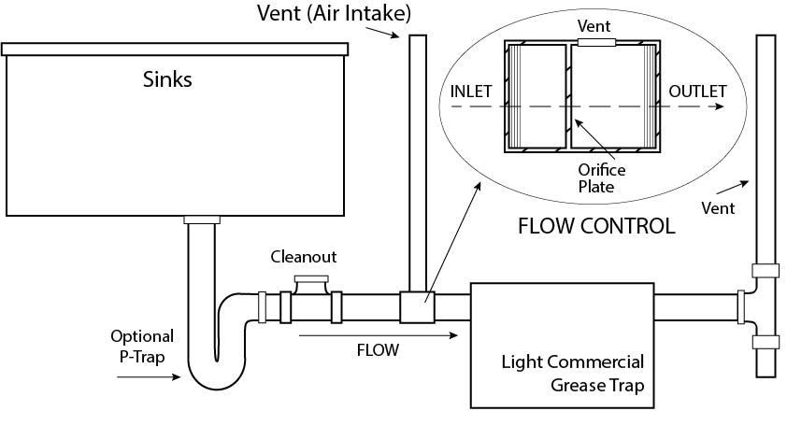

WHAT SIZE SHOULD THE GREASE TRAP BE?

Marion Utilities recommends consulting a licensed plumber to calculate grease trap sizing per plumbing code. Sizing is based on fats, oils, or grease generated and flow of water from the kitchen fixtures.

HOW DO I CLEAN MY GREASE TRAP?

All grease traps need to have the grease and solids removed periodically (daily to once a month). A cleaning schedule may be determined by measuring (in gallons) how much grease has been trapped over a period of time and calculating when the rated capacity for the grease trap is reached. (Grease will weigh about 7 pounds per gallon.) If the grease trap is more than 50% full when cleaned, then the cleaning frequency needs to be increased. The trap is maintained by removing the accumulated grease and other material, placing it in a sealed container, and taking it to Marion Utilities recycling center or disposing into the garbage dumpster. Do not pour boiling water down sinks to clean the grease trap.

Maintain a log of grease trap cleaning. Make the log available for inspection and submit to Marion Utilities, if requested. If a grease trap cleaning service is used, dated receipts must be available for inspection.

Some grease trap cleaning suggestions:

• Schedule grease trap cleaning during non-business hours because of potential odors.

• Frequent and proper cleaning makes the trap easier to clean and reduces odors.

• Procedure suggestions:

- Gather tools and containers

- Remove grease trap lid

- Do Not remove baffles until all contents are removed.

- Remove contents of trap, may use scoop or designated shop vac

- Place contents into tight sealing bucket for recycling at wastewater treatment plant

- Remove baffles

- Scrape the inside of the walls/baffles, do not use soap

- Remove scrapings

- Replace baffles

- Reseat gasket and replace and lid

- Use paper towel to clean grease from tools or spills

- Place tight lid on bucket

- Update your cleaning log

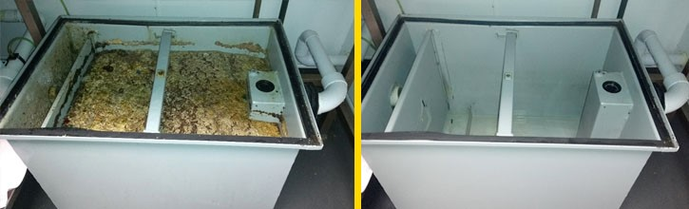- Place bucket in garbage or take to Marion Utilities

FOOD TRUCKS

Marion Utilities wants to ensure all food truck owners/operators understand the impact of improper disposal of gray water and some approved locations to empty their gray water tanks.

**What is gray water?**

Gray water is untreated waste water that has not come into contact with sanitary waste or other contaminated sources (Uniform Plumbing Code).

**What to do with your gray water:**

* Gray water must be dumped at an approved establishment into a drain that connects to a grease trap. Approved establishments are typically restaurants.
* If a restaurant isn’t an option for you, gray water tanks can be emptied out at the Marion Utilities Waste Water Treatment Plant.

**What not to do with your gray water:**

DO NOT dump gray water into a storm drain, on the ground, or directly into the city sewer. Improper disposal will plug the sewer system or contaminate rivers and streams.

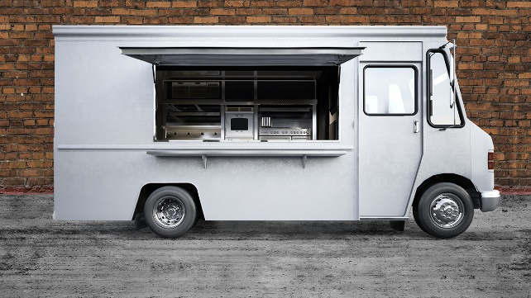

WHAT IS A SOLIDS SEPARATOR?

If you have a garbage disposal and a grease trap, then you need to install a solids separator to remove the solids so that they do not fill up your grease trap. A solids separator or solids interceptor is the piece of equipment that collects food debris and foreign particles that pass down the drain, preventing them from entering the grease trap.

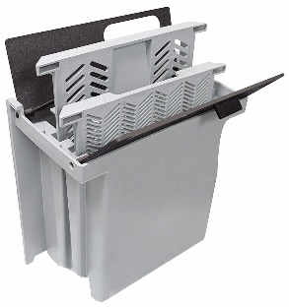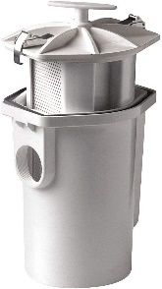

• Install after garbage disposal and prior to grease trap or grease interceptor.

• Size according to discharge rate of garbage disposal.

• Remove collected food and debris manually and at least daily, maybe more frequently.

WHAT MATERIALS CAN BE RECYCLED OR PROCESSED AT MARION UTILITIES?

**Cardboard, Glass, Metal, Plastic, and Paper** – Marion Utilities Recycling Center accepts glass bottles and jars, aluminum cans, steel cans, plastic food containers, cardboard boxes, paperboard boxes, and paper from rate payers within the City of Marion. If you are interested in recycling any of these materials, please contact Marion Utilities Environmental Resource Coordinator to work out a schedule and fees.

**Material removed from your grease interceptor** – The contractor that cleans your grease interceptor can bring the collected material to the Wastewater Treatment Plant Fats, Oils and Grease (FOG) receiving station. Marion Utilities pumps the material into anaerobic digesters where bacteria produce digester gas. The digester gas fuels an engine that powers a generator that produces enough electricity to meet almost ½ of the electricity demand at the Wastewater Treatment Plant.

**Materials removed from your grease trap** – If you have a grease trap and are cleaning it yourself or have a contractor clean it for you, bring the contents of your grease trap to Marion Utilities. Contact Marion Utilities Environmental Resource Coordinator to work out a drop off schedule that works for you.

**Food waste** – Some businesses and individuals are concerned about landfilling food waste. If that is a concern for you, Marion Utilities would like to discuss some options with you. The food waste must not contain any metal or plastic and may be brought in the same way that you bring in grease trap waste.

Marion Utilities may process food waste in anaerobic digesters that produce digester gas and biosolids. The digester gas is used to produce electricity at the wastewater treatment plant, like the material from your grease interceptor. The solid material from the process, called biosolids, are applied to farm fields for their nutrient and organic benefits. Marion Utilities may also have the ability to compost food waste.

Contact Marion Utilities Environmental Resource Coordinator to discuss options

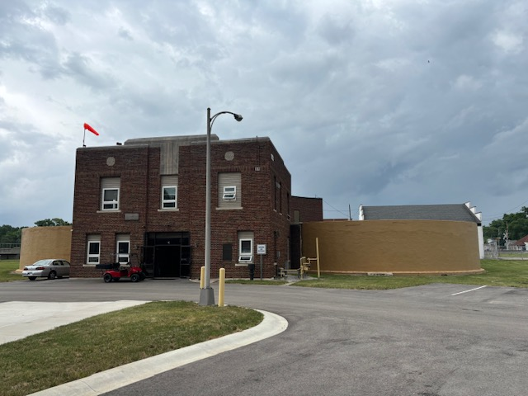

WHO DO I CONTACT IF I HAVE QUESTIONS?

Call Program Support at 765-664-2391 x128 or x105 or email pretreatment@marionutilities.com for questions regarding:

• Grease trap installation approval

• Grease interceptor cleaning frequency

• Food truck questions

• Record keeping requirements

Call Environmental Resources at 765-664-2391 x134 or email pkirklin@marionutilities.com for questions regarding:

• Contractors to clean grease interceptors

• Bringing grease interceptor, trap, or food waste to Marion Utilities

• Recycling cardboard, glass, metal, plastic and paper

*We look forward to working with you!*